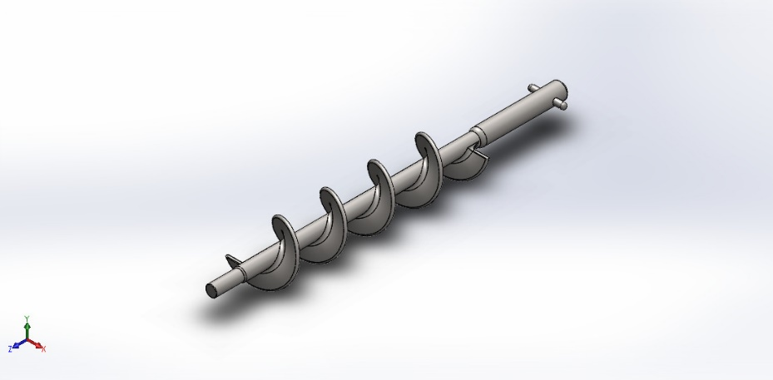
  Simulation of Auger
  Date: Thursday, April 9, 2026
  Designer: Solidworks
  Study name: Auger static analysis
  Analysis type: Static
  Table of Contents
  Description 1
  Assumptions 2
  Model Information 2
  Study Properties 3
  Units 3
  Material Properties 4
  Loads and Fixtures 4
  Connector Definitions 5
  Interaction Information 5
  Mesh information 5
  Sensor Details 5
  Resultant Forces 6
  Beams 6
  Study Results 7
  Conclusion 9

Description
No Data

Assumptions

Model Information

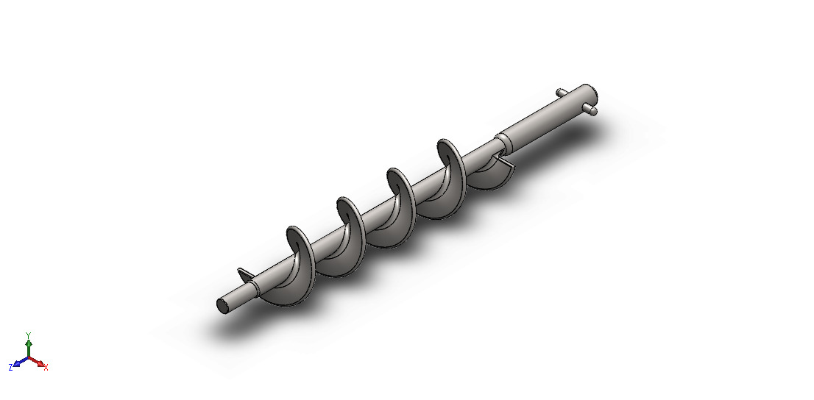
Model name: Auger
Current Configuration: Default
Solid Bodies
Document Name and Reference | Treated As | Volumetric Properties | Document Path/Date Modified
Fillet18  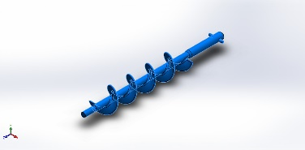 | Solid Body | Mass:1.17609 kg  Volume:0.00014702 m^3  Density:7,999.56 kg/m^3  Weight:11.5257 N | C:\Graduation graduate\Auger Filler of Powder VFFS\2. The second stage\AUGER FILLER SYSTEM\analysis\solidworks analysis\Auger analysis\Auger.SLDPRT  Apr 9 11:38:58 2026

Study Properties
Study name | Auger static analysis
Analysis type | Static
Mesh type | Solid Mesh
Thermal Effect: | On
Thermal option | Include temperature loads
Zero strain temperature | 298 Kelvin
Include fluid pressure effects from SOLIDWORKS Flow Simulation | Off
Solver type | Automatic
Inplane Effect: | Off
Soft Spring: | Off
Inertial Relief: | Off
Incompatible bonding options | Automatic
Large displacement | Off
Compute free body forces | On
Friction | Off
Use Adaptive Method: | Off
Result folder | SOLIDWORKS document (C:\Graduation graduate\Auger Filler of Powder VFFS\2. The second stage\AUGER FILLER SYSTEM\analysis\solidworks analysis\Auger analysis)

Units
Unit system: | SI (MKS)
Length/Displacement | mm
Temperature | Kelvin
Angular velocity | Rad/sec
Pressure/Stress | N/m^2

Material Properties
Model Reference | Properties | Components
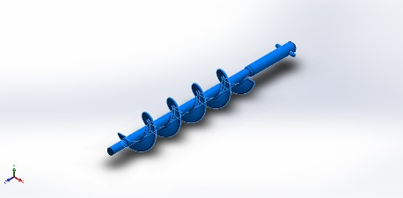 |  | SolidBody 1(Fillet18)(0.Auger (الطول الكلي 444سم))
  Name: | AISI 304
  Model type: | Linear Elastic Isotropic
  Default failure criterion: | Max von Mises Stress
  Yield strength: | 2.06807e+08 N/m^2
  Tensile strength: | 5.17017e+08 N/m^2
  Elastic modulus: | 1.9e+11 N/m^2
  Poisson's ratio: | 0.29
  Mass density: | 8,000 kg/m^3
  Shear modulus: | 7.5e+10 N/m^2
  Thermal expansion coefficient: | 1.8e-05 /Kelvin
Curve Data:N/A

Loads and Fixtures
Fixture name | Fixture Image | Fixture Details
Fixed-1 | 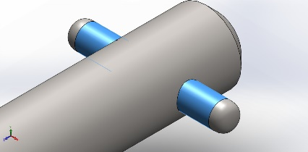
  Entities: | 2 face(s)
  Type: | Fixed Geometry
Resultant Forces
Components | X | Y | Z | Resultant
Reaction force(N) | -47.5094 | -1.3853 | -11.4987 | 48.9007
Reaction Moment(N.m) | 0 | 0 | 0 | 0

Load name | Load Image | Load Details
Torque-1 | 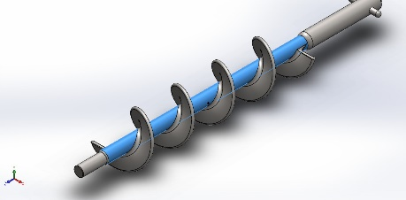
  Entities: | 1 face(s)
  Type: | Apply torque
  Value: | 20 N.m
Gravity-1 | 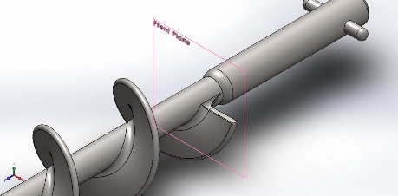
  Reference: | Front Plane
  Values: | 0 0 9.81
  Units: | m/s^2

Connector Definitions
No Data

Interaction Information
No Data

Mesh information
Mesh type | Solid Mesh
Mesher Used: | Blended curvature-based mesh
Jacobian points for High quality mesh | 16 Points
Maximum element size | 5.41099 mm
Minimum element size | 0.27055 mm
Mesh Quality | High

Mesh information - Details
Total Nodes | 104572
Total Elements | 63131
Maximum Aspect Ratio | 71.497
% of elements with Aspect Ratio < 3 | 99.3
Percentage of elements with Aspect Ratio > 10 | 0.0475
Percentage of distorted elements | 0
Time to complete mesh(hh;mm;ss): | 00:00:57
Computer name: | HASSAN

Sensor Details
No Data

Resultant Forces

Reaction forces
Selection set | Units | Sum X | Sum Y | Sum Z | Resultant
Entire Model | N | -47.5094 | -1.3853 | -11.4987 | 48.9007

Reaction Moments
Selection set | Units | Sum X | Sum Y | Sum Z | Resultant
Entire Model | N.m | 0 | 0 | 0 | 0

Free body forces
Selection set | Units | Sum X | Sum Y | Sum Z | Resultant
Entire Model | N | 0.580267 | -0.0988879 | -9.34634 | 9.36486

Free body moments
Selection set | Units | Sum X | Sum Y | Sum Z | Resultant
Entire Model | N.m | 0 | 0 | 0 | 1e-33

Beams
No Data

Study Results

Name | Type | Min | Max
Stress1 | VON: von Mises Stress | 9.295e+00N/m^2  Node: 42563 | 9.174e+07N/m^2  Node: 96867
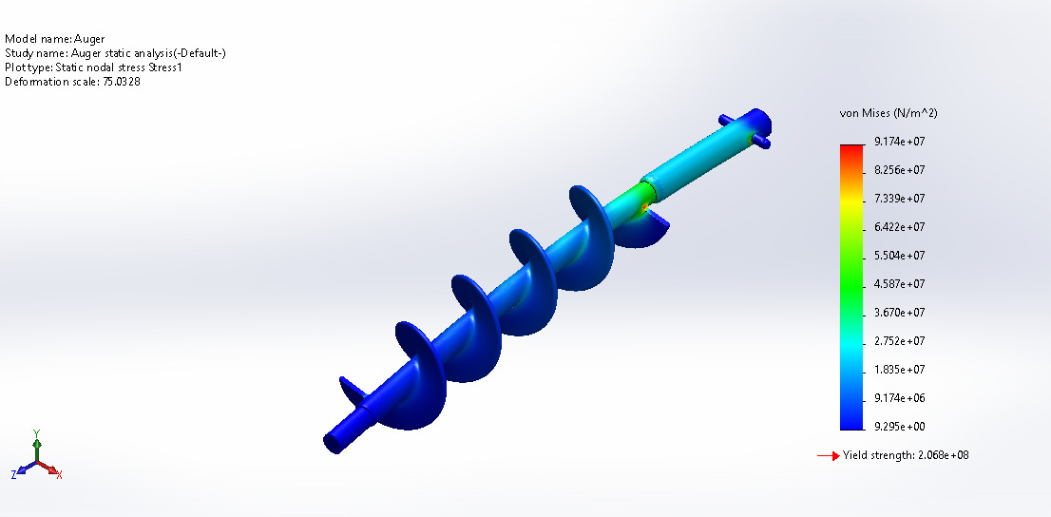
Auger-Auger static analysis-Stress-Stress1

Name | Type | Min | Max
Displacement1 | URES: Resultant Displacement | 0.000e+00mm  Node: 36 | 6.361e-01mm  Node: 42551
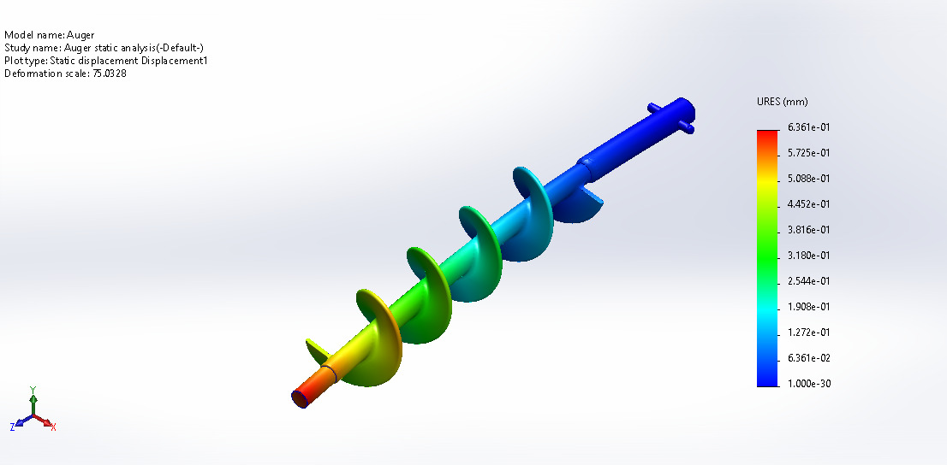
Auger-Auger static analysis-Displacement-Displacement1

Name | Type | Min | Max
Strain1 | ESTRN: Equivalent Strain | 2.029e-10  Element: 16819 | 3.776e-04  Element: 53648
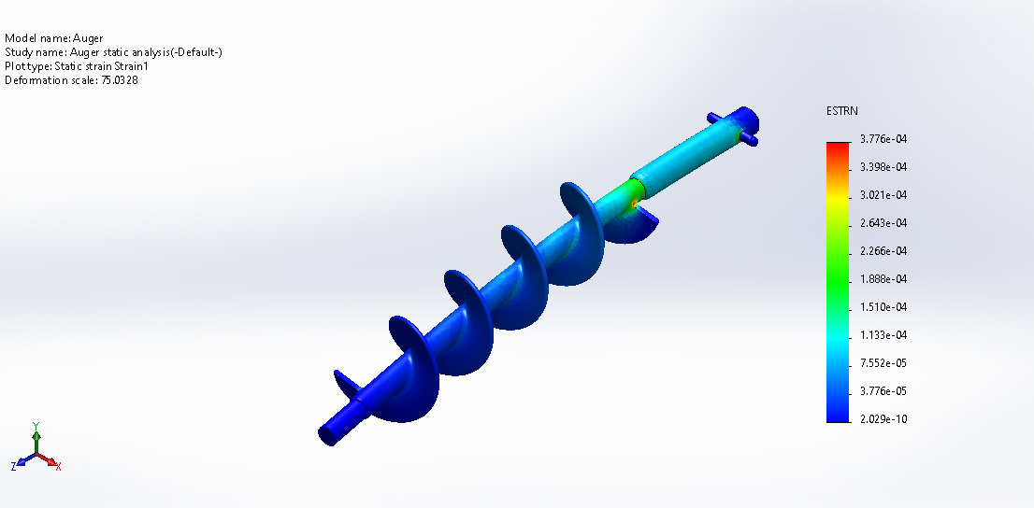
Auger-Auger static analysis-Strain-Strain1

Name | Type | Min | Max
Factor of Safety1 | Max von Mises Stress | 2.254e+00  Node: 96867 | 2.225e+07  Node: 42563
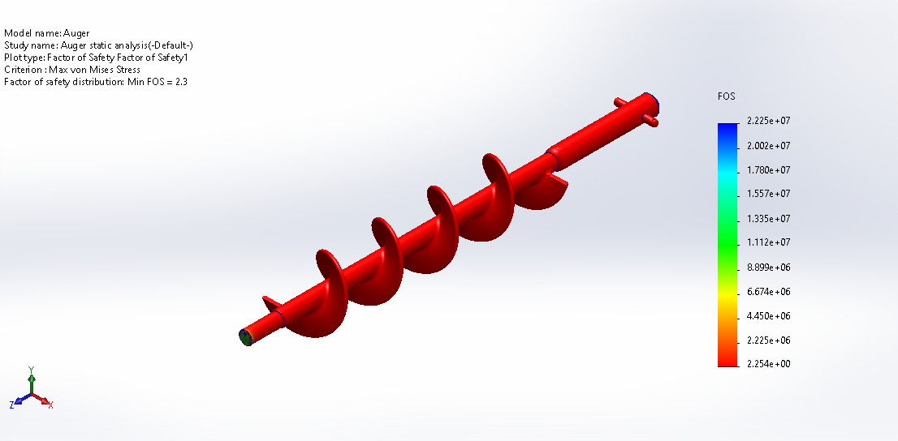
Auger-Auger static analysis-Factor of Safety-Factor of Safety1

Conclusion

